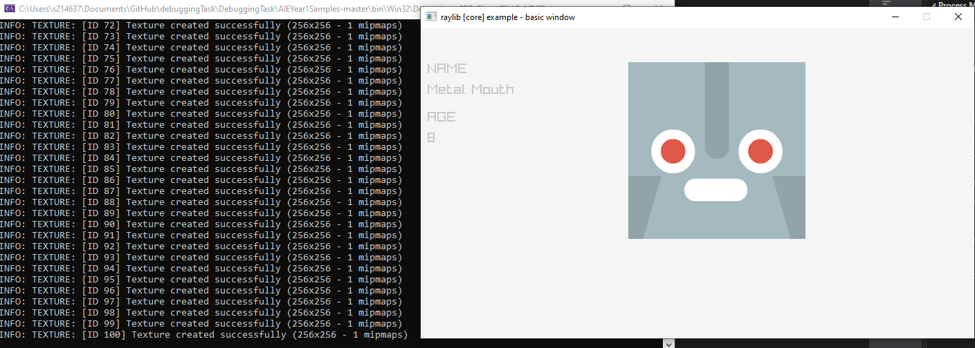

Pressed the right key 100 times, everything worked fine.

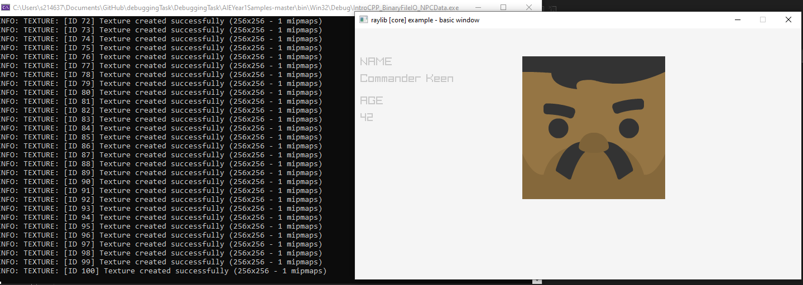

Pressed the left key 100 times, everything worked fine.

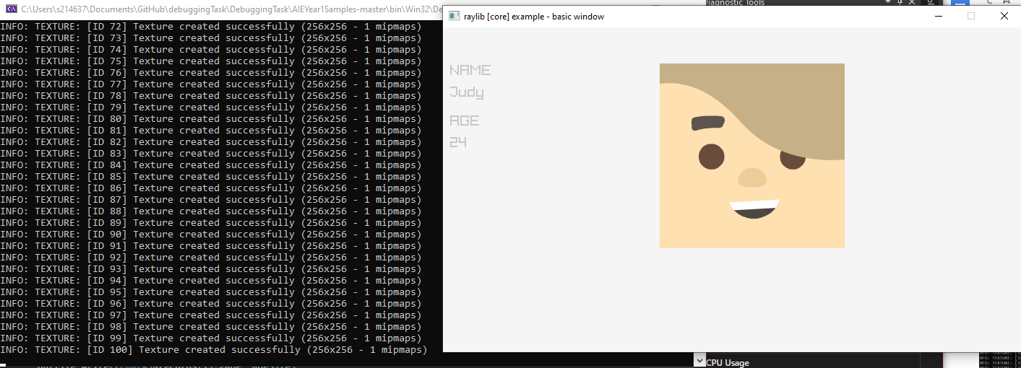

Pressed right then left and repeated 100 times, everything worked fine.

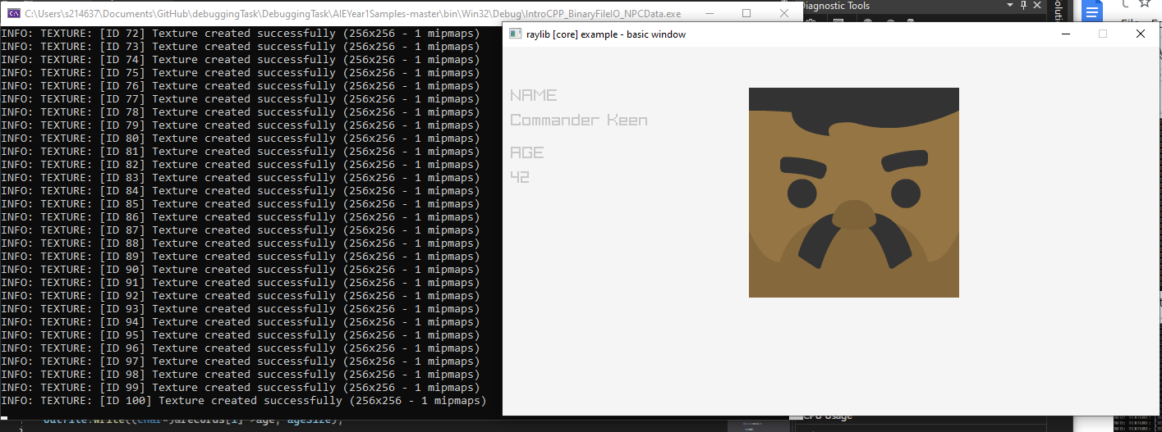

Pressed right 5 times then left 5 times till reached 100, everything worked fine.

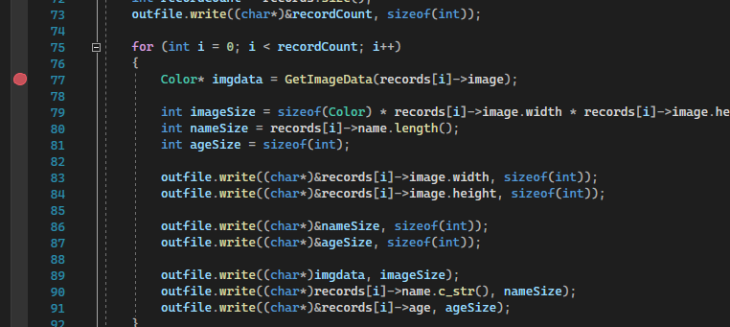

A break point

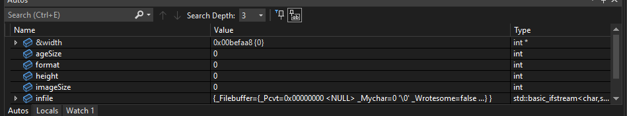

Auto watch points

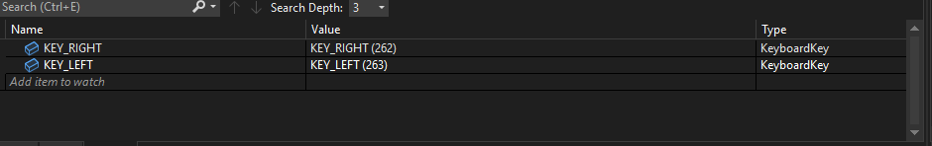

Custom watch points

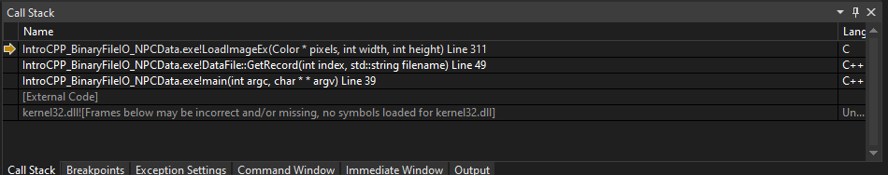

Callstack whilst debugging

The keyboard shortcuts for running through the code in debugging mode are, step into is F11, step over is F10, Step out is Shift + F11 and stop debugging is Shift + F5

**Version Control Documentation**

1. <https://github.com/Kazzysaurs/DebuggingTask.git>
2. <https://github.com/Kazzysaurs/DebuggingTask/commit/f7a8893f86d0fc9f84c51747bcd10c7729005506>
3. <https://github.com/Kazzysaurs/DebuggingTask/pulls>
4. a) i)small game businesses

ii)something cheaper easier to use

b) i)it's cheaper, less strain on the company, helps with more people knowing the game.

ii)specific problems that can't be helped by something like github can require someone to spend a lot of time and/or resources on something that really shouldn't.

1. Previous experience from perforce